1. **INTRODUCTION**

The development of a web-based application entitled “Latex Management” aims to develop an online rubber latex deliver web application for users which intend to provide almost all services and information about rubber planters in Kerala. It helps the users to buy rubber plants, latex collection, equipment’s, fertilizers and awareness which are necessary. This web application eliminates the needs for being physically present at rubber stores and farms to buy rubber plants, equipment, fertilizers, other needs and to sell rubber latex.

**1.1 RELEVANCE OF THE PROJECT**

My project entitled “LATEX MANAGEMENT” aims to develop an online rubber later deliver

site for users which intend to provide almost all services and information about rubber planters in

Kerala. It helps the users to buy rubber plants, latex collection, equipment’s, fertilizers and

awareness which are necessary. This site eliminates the needs for being physically present at

rubber stores and farms to buy rubber plants, equipment , fertilizers , other needs and to sell rubber

latex. The goal of the coding or programming phase is to translate the design of the system

produced during the design phase in to code in a given programming language, which can be

executed by a computer and that performs the computation specified by the design.

**1.2 PURPOSE**

This aims to develop an online rubber later deliver site for users which intend to provide almost all services and information about rubber planters in Kerala. It helps the users to buy rubber plants, latex collection, equipment’s, fertilizers and awareness which are necessary. This site eliminates the needs for being physically present at rubber stores and farms to buy rubber plants, equipment, fertilizers , other needs and to sell rubber latex.

To prepare a web application that provides all basic information and possible services to the

general planters in an online manner. The planters can inform the latex tin return, order the

equipment’s and can get knowledge on rubber market, fertilizers, etc. The application is an easy,

user friendly and a helpful web application for planters as well as others. The web application

offers services online with a single mouse click and it saves the precious time of the user.

**1.3 SCOPE OF THE PROJECT**

Changes in software engineering technology are indeed rapid. Future enhancement is concerned

when technology is changing. The existing system can be altered according to the user needs.

To prepare a web application that provides all basic information and possible services to the

general planters in an online manner. The planters can inform the latex tin return, order the

equipment’s and can get knowledge on rubber market, fertilizers, etc. The application is an easy,

user friendly and a helpful web application for planters as well as others. The web application

offers services online with a single mouse click and it saves the precious time of the user.

**1.4 PROBLEM STATEMENT AND DEFINITION**

In current scenario where government agencies are supporting digital

communication at a heavy rate and data storage and communication time are

being improved consequently, as a side effect, bad minds are getting more

chances of vulnerabilities. Steganography and cryptography has been leading

the front by concealing existence and meaning of the data respectively since a

long time. With the promotion of packet switched networks like internet, there

opens more doors towards moving to another level of steganography where

instead of using traditional digital data as cover ﬁle, some network protocol or

some other services plays the role of cover channel.

In current scenario where government agencies are supporting digital

communication at a heavy rate and data storage and communication time are

being improved consequently, as a side effect, bad minds are getting more

chances of vulnerabilities. Steganography and cryptography has been leading

the front by concealing existence and meaning of the data respectively since a

long time. With the promotion of packet switched networks like internet, there

opens more doors towards moving to another level of steganography where

instead of using traditional digital data as cover ﬁle, some network protocol or

some other services plays the role of cover channel

In current scenario where government agencies are supporting digital

communication at a heavy rate and data storage and communication time are

being improved consequently, as a side effect, bad minds are getting more

chances of vulnerabilities. Steganography and cryptography has been leading

the front by concealing existence and meaning of the data respectively since a

long time. With the promotion of packet switched networks like internet, there

opens more doors towards moving to another level of steganography where

instead of using traditional digital data as cover ﬁle, some network protocol or

some other services plays the role of cover channel

In current scenario where government agencies are supporting digital

communication at a heavy rate and data storage and communication time are

being improved consequently, as a side effect, bad minds are getting more

chances of vulnerabilities. Steganography and cryptography has been leading

the front by concealing existence and meaning of the data respectively since a

long time. With the promotion of packet switched networks like internet, there

opens more doors towards moving to another level of steganography where

instead of using traditional digital data as cover ﬁle, some network protocol or

some other services plays the role of cover channel

In current scenario where government agencies are supporting digital

communication at a heavy rate and data storage and communication time are

being improved consequently, as a side effect, bad minds are getting more

chances of vulnerabilities. Steganography and cryptography has been leading

the front by concealing existence and meaning of the data respectively since a

long time. With the promotion of packet switched networks like internet, there

opens more doors towards moving to another level of steganography where

instead of using traditional digital data as cover ﬁle, some network protocol or

some other services plays the role of cover channel

In current scenario where government agencies are supporting digital

communication at a heavy rate and data storage and communication time are

being improved consequently, as a side effect, bad minds are getting more

chances of vulnerabilities. Steganography and cryptography has been leading

the front by concealing existence and meaning of the data respectively since a

long time. With the promotion of packet switched networks like internet, there

opens more doors towards moving to another level of steganography where

instead of using traditional digital data as cover ﬁle, some network protocol or

some other services plays the role of cover channel.

In current scenario where government agencies are supporting digital

communication at a heavy rate and data storage and communication time are

being improved consequently, as a side effect, bad minds are getting more

chances of vulnerabilities. Steganography and cryptography has been leading

the front by concealing existence and meaning of the data respectively since a

long time. With the promotion of packet switched networks like internet, there

opens more doors towards moving to another level of steganography where

instead of using traditional digital data as cover ﬁle, some network protocol or

some other services plays the role of cover channel.

In current scenario where government agencies are supporting digital

communication at a heavy rate and data storage and communication time are

being improved consequently, as a side effect, bad minds are getting more

chances of vulnerabilities. Steganography and cryptography has been leading

the front by concealing existence and meaning of the data respectively since a

long time. With the promotion of packet switched networks like internet, there

opens more doors towards moving to another level of steganography where

instead of using traditional digital data as cover ﬁle, some network protocol or

some other services plays the role of cover channel.

In current scenario where government agencies are supporting digital

communication at a heavy rate and data storage and communication time are

being improved consequently, as a side effect, bad minds are getting more

chances of vulnerabilities. Steganography and cryptography has been leading

the front by concealing existence and meaning of the data respectively since a

long time. With the promotion of packet switched networks like internet, there

opens more doors towards moving to another level of steganography where

instead of using traditional digital data as cover ﬁle, some network protocol or

some other services plays the role of cover channel.

In current scenario where government agencies are supporting digital

communication at a heavy rate and data storage and communication time are

being improved consequently, as a side effect, bad minds are getting more

chances of vulnerabilities. Steganography and cryptography has been leading

the front by concealing existence and meaning of the data respectively since a

long time. With the promotion of packet switched networks like internet, there

opens more doors towards moving to another level of steganography where

instead of using traditional digital data as cover ﬁle, some network protocol or

some other services plays the role of cover channel.

In current scenario where government agencies are supporting digital

communication at a heavy rate and data storage and communication time are

being improved consequently, as a side effect, bad minds are getting more

chances of vulnerabilities. Steganography and cryptography has been leading

the front by concealing existence and meaning of the data respectively since a

long time. With the promotion of packet switched networks like internet, there

opens more doors towards moving to another level of steganography where

instead of using traditional digital data as cover ﬁle, some network protocol or

some other services plays the role of cover channel.

In current scenario where government agencies are supporting digital

communication at a heavy rate and data storage and communication time are

being improved consequently, as a side effect, bad minds are getting more

chances of vulnerabilities. Steganography and cryptography has been leading

the front by concealing existence and meaning of the data respectively since a

long time. With the promotion of packet switched networks like internet, there

opens more doors towards moving to another level of steganography where

instead of using traditional digital data as cover ﬁle, some network protocol or

some other services plays the role of cover channel.

In current scenario where government agencies are supporting digital

communication at a heavy rate and data storage and communication time are

being improved consequently, as a side effect, bad minds are getting more

chances of vulnerabilities. Steganography and cryptography has been leading

the front by concealing existence and meaning of the data respectively since a

long time. With the promotion of packet switched networks like internet, there

opens more doors towards moving to another level of steganography where

instead of using traditional digital data as cover ﬁle, some network protocol or

some other services plays the role of cover channel.

In current scenario where government agencies are supporting digital

communication at a heavy rate and data storage and communication time are

being improved consequently, as a side effect, bad minds are getting more

chances of vulnerabilities. Steganography and cryptography has been leading

the front by concealing existence and meaning of the data respectively since a

long time. With the promotion of packet switched networks like internet, there

opens more doors towards moving to another level of steganography where

instead of using traditional digital data as cover ﬁle, some network protocol or

some other services plays the role of cover channel.

System design is the process of defining the architecture, components, modules, interfaces, and

data for a system to satisfy specified requirements. Systems design could be seen as the application of systems theory to product development. Currently there doesn’t have any online system for the operation. The web application is informative but not productive. Bills of latex are sent through postal after 15 days from purchase date. Contents are static does not receive frequent updates.

**1.5 OBJECTIVE OF THE STUDY**

The application is an easy, user friendly and a helpful web application for planters as well as others. The web application offers services online with a single mouse click and it saves the precious time of the user.

1. **EXISTING SYSTEM**

Firstly, a detailed study of existing system was performed. The existing system is manual, the customers have to visit the dealers company or inform the planters about taken latex tin after 2 or 3 days through planters. The planters have no idea about the latex rate provide by companies.

Limitations of existing system

* Manually operated.
* Service are limited.
* The site is informative but not productive.
* Bills of latex are send through postal after 15 days from purchase date.
* Contents are static does not receive frequent updates.

1. **PROPOSED SYSTEM**

To prepare a website that provides all basic information and possible services to the general planters in an online manner. The planters can inform the latex tin return, order the equipment’s and can get knowledge on rubber market, fertilizers, etc. This is an easy, user friendly and a helpful website for planters as well as others. This website offers services online with a single mouse click. It saves the precious time of the user.

Advantages of Proposed System

* Easy to use.
* User Friendly.
* Informative.
* Offers purchase of fertilizer, equipment’s, etc. online.
* Provides awareness, instructions and precautions.
* 24X7 accessibility.
* After each purchase of latex from plantation, update the users profile with new data’s.
* The payment of rubber is through online banking.
* The data of each tin is recorded separately.

1. **LITERATURE REVIEW**

# **1. “Management of latex reactions in the occupational setting” by Aaohn J**,

1998.

1. The increased use of natural rubber latex barrier protection to prevent exposure to blood borne pathogens has led to an increase in latex related health reactions, particularly associated with glove use. 2. The three types of reactions to latex in order of frequency include irritant contact dermatitis, allergic contact dermatitis, and immediate systemic/anaphylaxis reactions. 3. The management goal for all reactions is to avoid unnecessary restriction from the appropriate use of latex (gloves) which provides the best barrier protection, while protecting individual workers from exposure that results in sensitization or causes sensitized individuals to have serious reactions. 4. Choose non-latex gloves when barrier protection from blood borne pathogens is not an issue. When selecting a latex glove, choose a glove that is low in proteins and powder free to control airborne latex exposure.

**5. SYSTEM REQUIRMENTS AND SPECIFICATIONS**

The System Requirements Specification document lays out all of the data, functional, and behavioral requirements for the software in development or production. The functionality of a system or one of its subsystems is defined in a functional requirement document. It also relies on the type of programmer, the number of expected users, and the machine on which the software is installed. A non-functional requirement is one that sets criteria rather than specific behaviors that can be used to judge the operation of a system.

* 1. **GENERAL DESCRIPTION OF SYSTEM**
     1. **OVERVIEW OF FUNCTIONAL REQUIREMENTS**

**OVERVIEW OF DATA REQUIREMENTS**

These are the quality restrictions that the system must meet in order to meet the project's objectives. Non-behavioral requirements are also known as non-functional requirements.

* **Reliability**

In order to provide the functionalities, the structure must be reliable and sturdy. When a consumer has revealed a couple of improvements, the structure must make the actions clear. The Programmer's advancements must include Project pioneering as well as Test designer.

* **Maintainability**

The monitoring and maintenance of the system should be fundamental and focused in its approach. There should not be an excessive number of jobs running on several machines, making it difficult to monitor if the jobs are operating smoothly.

* **Performance**

Throughout the process, multiple representatives will use the framework. Because the system will be run on a single web server with a single database server that will be hidden from view, execution becomes a major concern. When various clients would employ everything at the same time, the structure should not succumb. It should provide quick access to each and every one of its clients' items. For example, if two test specialists are attempting to report the location of a bug at the same time, there should not be any inconsistency.

* **Portability**

The framework should be adaptable to a variety of other frameworks. This is required when the web server that facilitates the framework becomes unresponsive due to a number of reasons, necessitating the framework's migration to another framework.

* **Scalability**

The architecture should be flexible enough to allow for the addition of additional features in the future. There should be a standard channel that can accommodate the new features.

* **Flexibility**

Flexibility refers to a framework's ability to adapt to changing settings and circumstances, as well as changes in corporate practises and rules. Because of the various client and framework requirements, an adaptable framework is not difficult to reconfigure or alter. Because only a small portion of the framework is affected when methods or principles change, the deliberate split of concerns between the trough and motor sections aids flexibility.

* 1. **TECHNICAL REQUIREMENTS OF THE SYSTEM**

**5.2.1 Hardware Requirements**

* System Processor: Any x86/x64 based microprocessor
* Hard Disk: Minimum of 80GB
* Ram: 512MB or Greater
  + 1. **Software Requirements**
* Operating system: Any Operating System
* Programming Language: PHP
* Software Package: WAMP
  1. **LANGUAGE SPECIFICATION**

**5.3.1 PHP**

PHP has a lot of unique features because it can do anything related to server-side programming, which includes the backend of any web page. Web development is the primary goal of PHP design. PHP began as a small open-source project that grew in popularity as more people realized how useful it was. In 1994, Rasmus Lerdorf released the first version of PHP.

* PHP is a recursive acronym for "PHP: Hypertext Preprocessor".
* PHP is a server-side scripting language that is embedded in HTML. It is used to manage dynamic content, databases, session tracking, even build entire e-commerce sites.
* It is integrated with a number of popular databases, including MySQL, PostgreSQL, Oracle, Sybase, Informix, and Microsoft SQL Server.
* PHP is pleasingly zippy in its execution, especially when compiled as an Apache module on the Unix side. The MySQL server, once started, executes even very complex queries with huge result sets in record-setting time.
* PHP supports a large number of major protocols such as POP3, IMAP, and LDAP. PHP4 added support for Java and distributed object architectures (COM and CORBA), making n-tier development a possibility for the first time.
* PHP is forgiving: PHP language tries to be as forgiving as possible.
* PHP Syntax is C-Like.

Common uses of PHP are:

* PHP performs system functions, i.e., from files on a system it can create, open, read, write, and close them.
* PHP can handle forms, i.e., gather data from files, save data to a file, through email you can send data, return data to the user.
* You add, delete, modify elements within your database through PHP.
* Access cookies variables and set cookies.
* Using PHP, you can restrict users to access some pages of your website.
* It can encrypt data.

The unique features of PHP are:

* **Simple, Familiar and ease of use**

Because the syntax is comparable to those of 'C' or Pascal, it is well-known for its simplicity, familiarity, and ease of learning. As a result, the language is a well-organized and logical general-purpose programming language. Even persons with no prior programming experience can readily grasp and understand the use of language. PHP is ideal for newcomers since it is dependable, fluent, organized, clean, demandable, and efficient.

* **Loosely typed language**

Without specifying its data types, PHP encourages the use of variables. As a result, depending on the value assigned to the variable, this is taken care of during execution. The name of the variable can be modified dynamically as well.

* **Flexibility**

**PHP is noted for its versatility and embedded nature, as it can work with HTML, XML, JavaScript, and a variety of other languages. PHP is compatible with a variety of operating systems, including Windows, Unix, Mac OS, Linux, and others. PHP scripts can operate on a variety of devices, including laptops, mobile phones, tablets, and computers. It integrates well with a variety of databases. Advanced PHP features are used to construct desktop applications. The PHP executable can be run from the command line or directly on the system. Without the use of a server or a browser, heavyweight apps can be constructed.**

* **Open Source**

All PHP frameworks are open source, which means that users don't have to pay anything and can use them for free. Users can simply download PHP and begin utilizing it in their projects or applications. Even in businesses, the entire cost of software development is lowered, resulting in increased reliability and flexibility. It supports a variety of databases, including MySQL, SQLite, Oracle, Sybase, Informix, and PostgreSQL, and provides libraries for interacting with these databases via web servers. Developers are free to report bugs, check codes, and contribute to code development. PHP is used by many frameworks, including Codeignitor, Zend Framework, and CakePHP. PHP is the primary language used by many prominent content management systems, including WordPress, Joomla, and Drupal. Many web hosting firms and Internet service providers favour PHP for the reasons stated above.

* **Cross-platform compatibility**

PHP is a multi-platform programming language that can run on any operating system and in any Windows environment. XAMPP (Windows, Apache Server, MySQL, Perl, and PHP) and LAMP (Linux, Apache Server, MySQL, Perl, and PHP) are the most popular (Linux, Apache, MySQL, PHP). Because PHP is platform-agnostic, it's simple to interact with a variety of databases and other technologies without having to re-implement them. It saves a significant amount of energy, time, and money.

* **Active community support**

PHP has a large online community of developers who can assist newcomers with web-based applications. These people from all across the world contribute a variety of features as well as new versions of PHP libraries. They even give translations in many languages to assist programmers. There is a collection of open-source libraries from third parties that provide basic functionality. Even the official site's documentation aids in the implementation of new features, giving users access to a wide range of creative ideas.

* **Fast and efficient performance**

Users want websites that load quickly. For any web construction, speed is a key consideration, which PHP addresses.

* **Maintenance**

When working on large projects, code maintenance is also a crucial part of the web development process. There are a variety of PHP frameworks available, such as MVC (Model View Controller), that make code development and maintenance easier. The files relating to each module are kept in their own folders.

* **Third-party application support and security**

Many of PHP's built-in functions offer data encryption, making it more secure. Users can also use third-party applications to protect their data.

* **Real time access monitoring**

 PHP also provides a summary of user’s recent logging accesses.

* **Object oriented features**

PHP supports object-oriented programming features, resulting in increased speed and introducing added features like data encapsulation and inheritance at many levels.

* + 1. **MYSQL**

A database is a stand-alone programme that stores a set of data. For creating, accessing, managing, searching, and duplicating the data it holds, each database includes one or more APIs. Other types of data stores, such as files on a file system or massive hash tables in RAM, can also be employed, although data reading and writing would be slower and more difficult.

To store and handle large amounts of data, we now employ relational database management systems (RDBMS). Because all of the data is stored in various tables and relationships are made using primary keys or additional keys known as Foreign Keys, this is referred to as a relational database. A Relational Database Management System (RDBMS) is a piece of software that allows you to manage your databases.

* Enables you to implement a database with tables, columns and indexes.
* Guarantees the Referential Integrity between rows of various tables.
* Updates the indexes automatically.
* Interprets an SQL query and combines information from various tables.

**5.5.2 WAMP**

**WampServer** is meant by constituting WAMP + SERVER, now here Wamp is a short form for **“Windows, Apache, MySQL and PHP”** whereas the Server simply means a Computer program that provides services to other applications or clients.

Windows which is an ultimate platform for beginners and advanced users to operate, process and

manage the different day to day computing tasks, however, if you are a developer and want to

experience some of the most powerful software without paying a single penny then you should

think about **Linux**. There are so many software packages that are only designed to run efficiently

on Linux platforms such as Apache web server, PHP interpreter and MySQL database (LAMP).

Now, the thing if we have a Windows 10/8.1/8/7 system and we don’t want to change our

operating system to Linux for testing Web or PHP applications or learning the curves of MySQL.

In such a case, the WAMP server comes handy.

In general, developers or users use the WAMPserver for testing various web applications or

websites locally before making them live using WAMP. For example, you want to create a

website on WordPress but before going live your website or purchasing hosting you can

learn [how to install WordPress](https://www.how2shout.com/wordpress-tutorial/how-install-wordpress-locally-using-wamp.html), setting themes etc. locally using WAMPserver.

Thus, for the ease of users especially newbies to create dynamic websites the developers of this

software have integrated:

**6. SYSTEM DESIGN AND ANALYSIS**

**INTRODUCTION**

System design is the process of defining the architecture, components, modules, interfaces, and data for a system to satisfy specified requirements. Systems design could be seen as the application of systems theory to product development**.**

**PROCESS DESIGN**

**Modules:**

**Admin login:** The system is under supervision of admin who check and manage the dealers.

**User’s login:** Users are the dealers or planters.

**USE CASE DIAGRAM**

The unified modeling language (UML) is a non-proprietary, object modeling and specification language used for software engineering.UML includes a standardized graphical notation that may use to create abstract model of the system.

Use cases are used during the analysis phase of the project to identify and partition system functionally. They separate the system in to actors and use cases.

Actors:-Actors play the role of the users of the system.

Actor

**Use case**: -Thebehavior of the system when one of these actors send one particular stimulus.

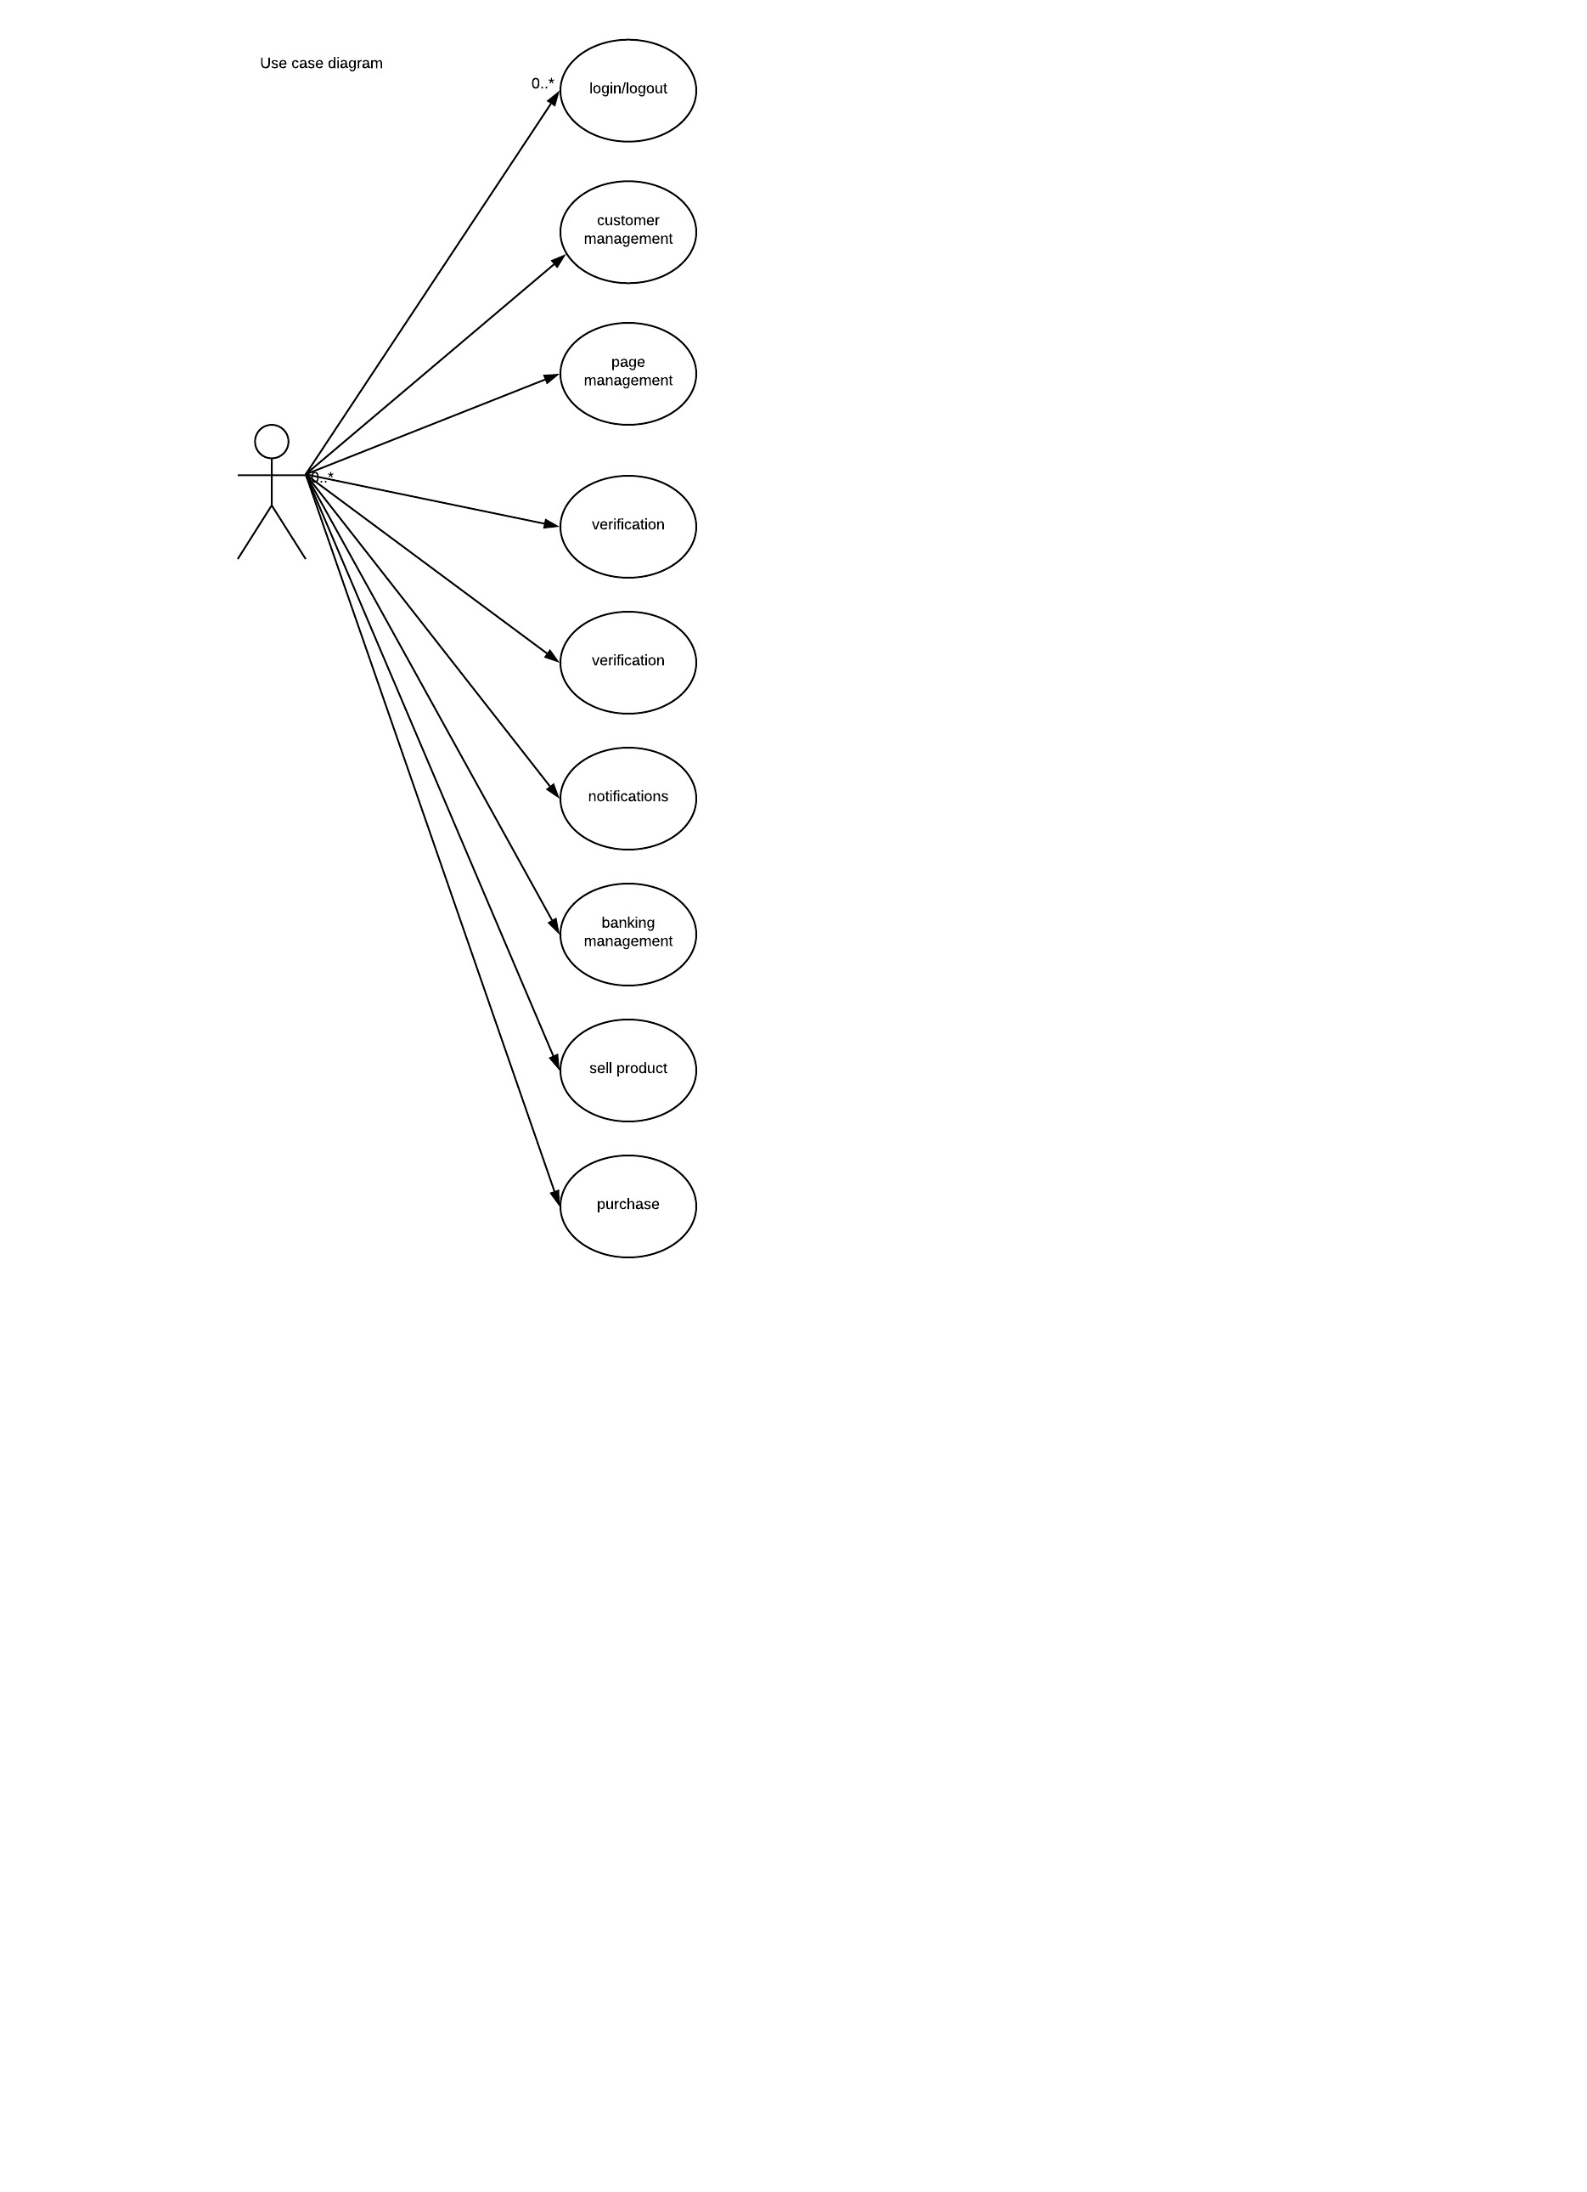

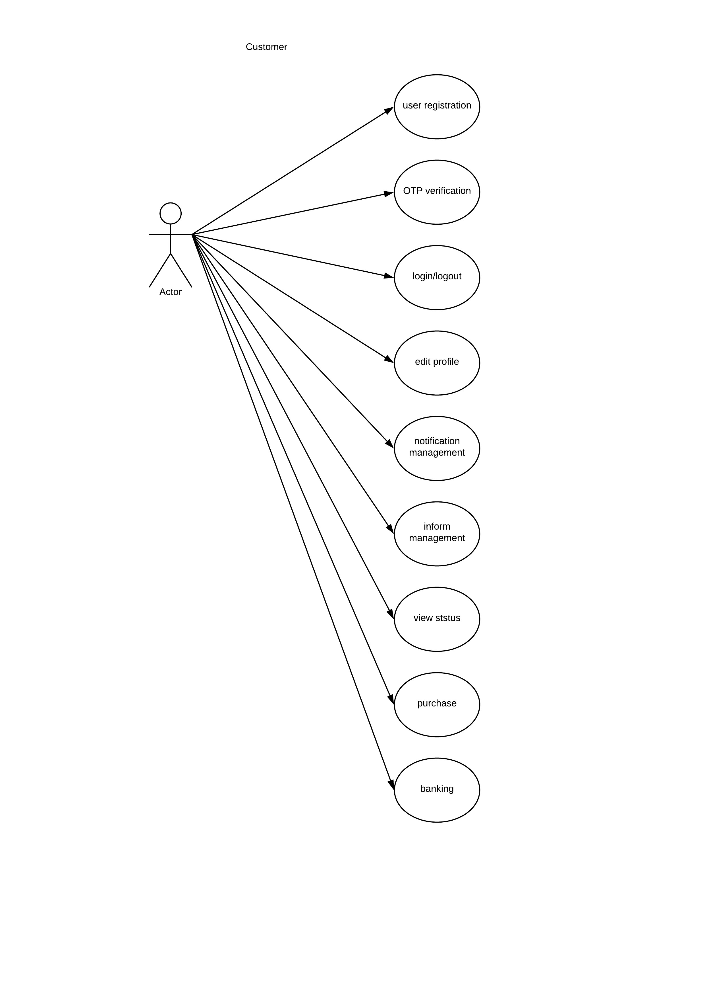

**DATA FLOW DIAGRAM**

A data flow diagram shortly termed as DFD has the purpose of clarifying system requirements and identifying major transformations that will becomes programs in system design. So it is a design phase that functionally decomposes the requirement specifications down to the lowest level of detail. The DFD is known as Data Flow Graph or Bubble Chart. It is the starting point of the design phase that functionally decomposes the requirement specifications down to the level of details.

The merit of the DFD is that it can provide an overview of the data to be processed by the system, the data to be transformed, the files to be used and the flow of data along the system. It has illustrating the essential component of the process and the way of interaction.

DFDs mainly use the following symbols:

Circles are used to represent process that convert data into information.

Rectangles are used to represent external entities, which are the sources of data that enter the system or the recipient of data that leave the system.

Open rectangles are used for representing databases.

Arrows are used to represent the data flow. Data flows represent the movement’s data between other components.

**LEVEL 0**

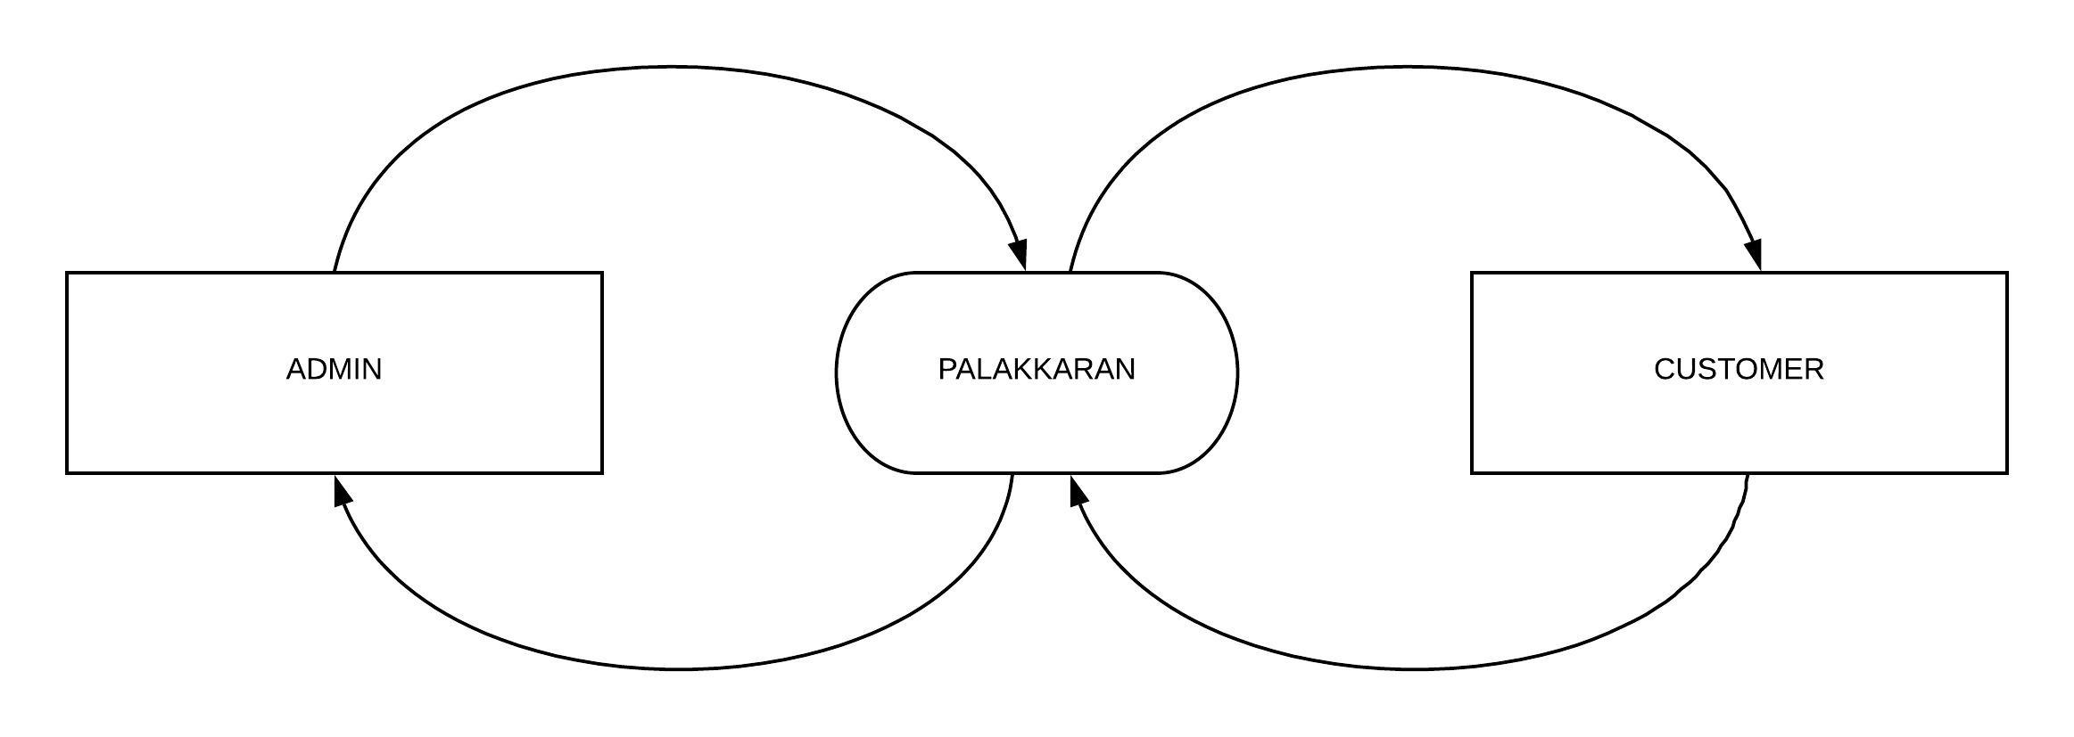

**LEVEL 1**

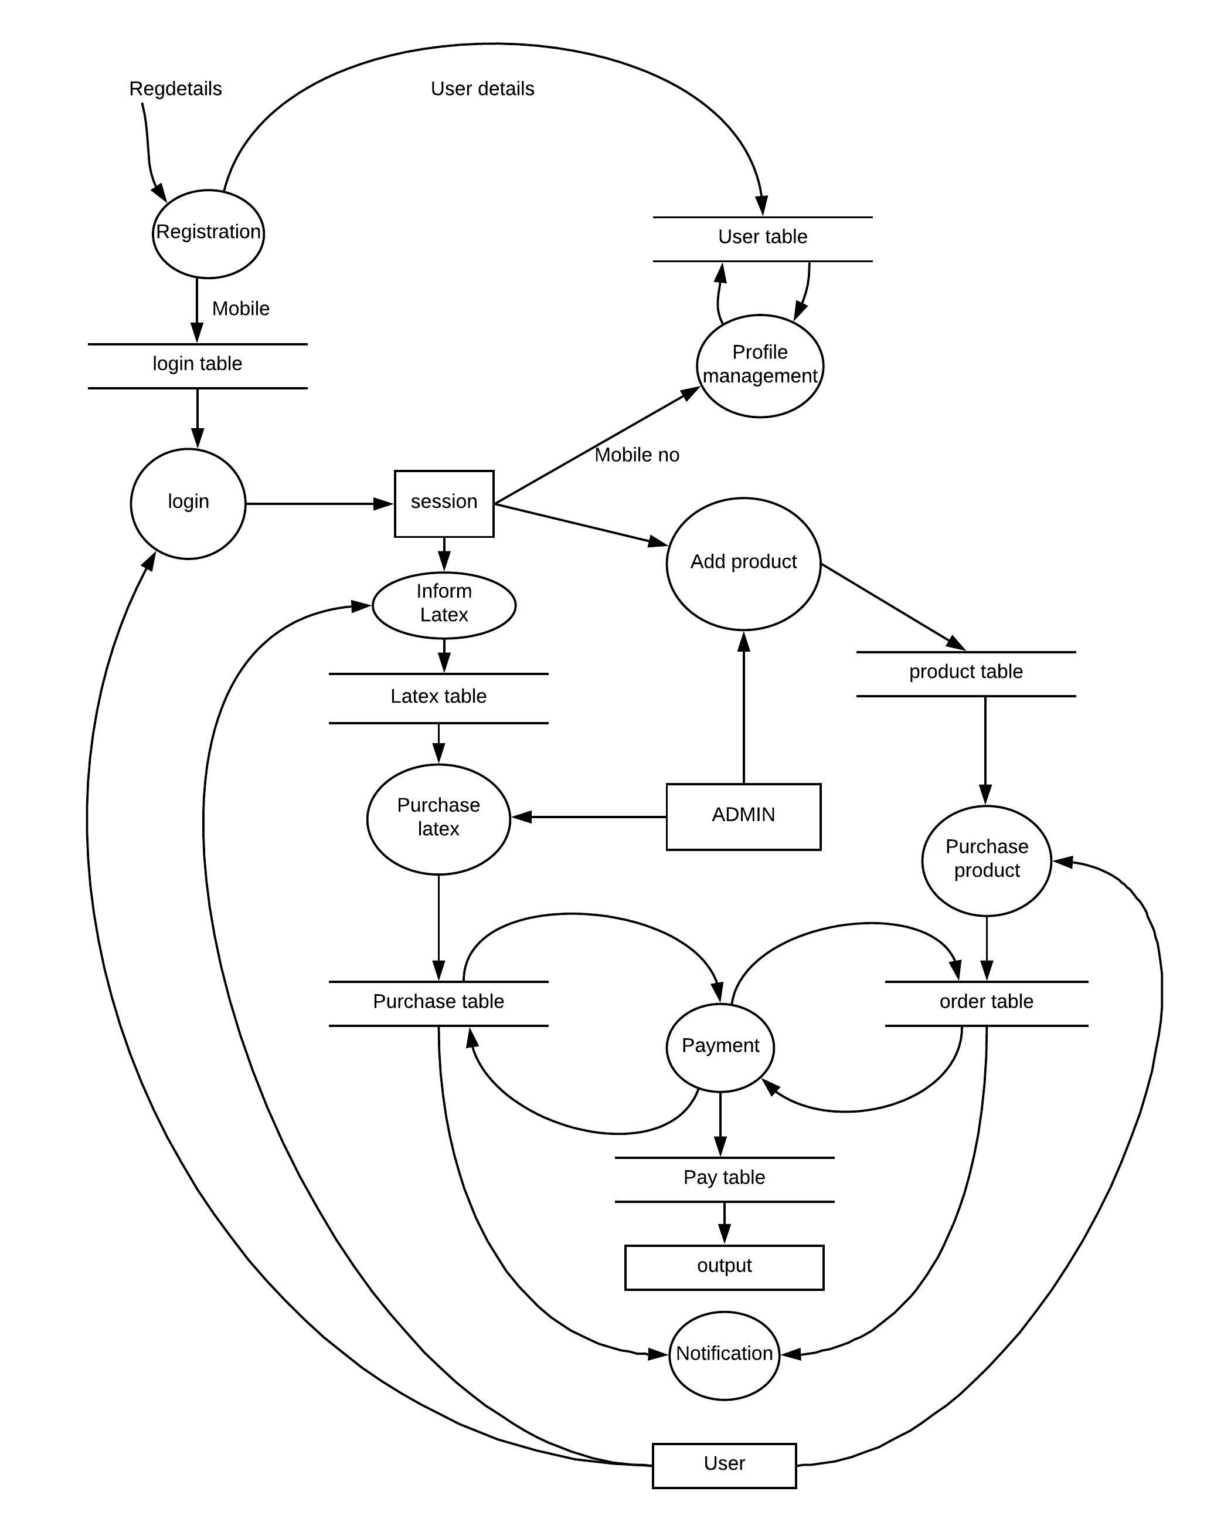

**DATABASE DESIGN**

* **TABLE NAME : PEOPLE**

|  |  |  |  |
| --- | --- | --- | --- |
| Fields | Type | Key | Description |
| F_name | Varchar(20) | Not null | First name |
| L_name | Varchar(10) | Not null | Last name |
| Email | Varchar(20) | Unique | Email id |
| Mob | Int(10) | Primary key | Mobile number |
| Pswd | Varchar(20) | Not null | Password |
| People_id | Int(10) | Primary key | People user id |

* **TABLE NAME : ORGANISATION**

|  |  |  |  |
| --- | --- | --- | --- |
| Fields | Type | Key | Description |
| Org_Name | Varchar(30) | Not null | Organization Name |
| Addr | Varchar(50) | Not null | Address |
| Loc | Varchar(15) | Not null | Locality |
| Dist | Varchar(10) | Not null | District |
| Email | Varchar(20) | Unique | Email id |
| Mob | Int(10) | Not null | Mobile number |
| Org_RegNo | Int(10) | Not null | Organization RegNo |
| Pswd | Varchar(20) | Not null | Password |
| Org_id | Int(10) | Primary key | Organisation id |

* **TABLE NAME : AGENT**

|  |  |  |  |
| --- | --- | --- | --- |
| Fields | Type | Key | Description |
| Name | Varchar(20) | Not null | Agent Name |
| Addr | Varchar(50) | Not null | Address |
| Loc | Varchar(15) | Not null | Locality |
| Dist | Varchar(15) | Not null | District |
| Email | Varchar(20) | Unique | Email id |
| Mob | Int(10) | Not null | Mobile number |
| Ag_id | Int(10) | Primary key | Agent id |

* **TABLE NAME : AGENT – LABOURER CATEGORY**

|  |  |  |  |
| --- | --- | --- | --- |
| Field | Type | Key | Description |
| Lab_id | Int(10) | Primary key | Labour id |
| Category | Varchar(20) | Not null | Labour category |
| Labr_no | Int(10) | Not null | Max no of labourers |
| Agent_id | Int(10) | Foreign key | Agent id |

* **TABLE NAME : LABOURER**

|  |  |  |  |
| --- | --- | --- | --- |
| Field | Type | Key | Description |
| F_name | Varchar(15) | Not null | First name |
| L_name | Varchar(15) | Not null | Last name |
| Addr | Varchar(50) | Not null | Address |
| Loc | Varchar(15) | Not null | Locality |
| Dist | Varchar(15) | Not null | District |
| Gen | Varchar(1) | Not null | Gender |
| Age | Int(2) | Not null | Age |
| Mob | Int(10) | Not null | Mobile number |
| Labr_id | Int(10) | Primary key | Labours unique id |

* **TABLE NAME :LABR_CATEGORY**

|  |  |  |  |
| --- | --- | --- | --- |
| Field | Type | Key | Description |
| Labr_id | Int(10) | Foreign key | Labour id |
| Category | Varchar(20) | Primary key | Category |

* **TABLE NAME : CATEGORY**

|  |  |  |  |
| --- | --- | --- | --- |
| Field | Type | Key | Description |
| Cat_name | Varchar(20) | Not null | Category name |
| Cat_id | int(10) | Primary Key | Category id |

* **TABLE NAME : ITEM**

|  |  |  |  |
| --- | --- | --- | --- |
| Field | Type | Key | Description |
| IT_id | Int(11) | Primary key | Item id |
| IT_name | Varchar(20) | Not null | Item name |
| Cat_id | int(10) | Foreign key | Category ID |
| Img | Varchar(10) | Not null | Image |
| Rate | Int(11) | Not null | Rate |
| Qty | Int(5) | Not null | Quantity |
| Email | Varchar(20) | Foreign key | Seller name |

**7. IMPLEMENTATION**

Implementation is one of the most important task in a project. Implementation is the face, in which one of has to be cautious, because all the efforts under taken during this project will be fruitful only if the software is properly implemented according to the plans made.

Implementation is the stage in the project where theoretical design is turned in to a working system. The crucial stage is achieving successful new system and given to the users confidence in that system will work effectively and efficiently.

**8. USER INTERFACE DIAGRAM**

**LOGIN**

Login page

Mobile no :

Password :

Remember

Cancel

Login

Forgot Password ?

OTP Verification

Register now

**OTP VERIFICATION**

OTP Verification

Mobile no :

Password :

OTP :

Submit

**9.** **SCREENSHOTS**

**REGISTRATION**

Registration

Name :

Mobile number :

Permanent address :

Temp address :

Email :

Password :

Re password :

Register

**SCREENSHOTS**

**LOGIN**

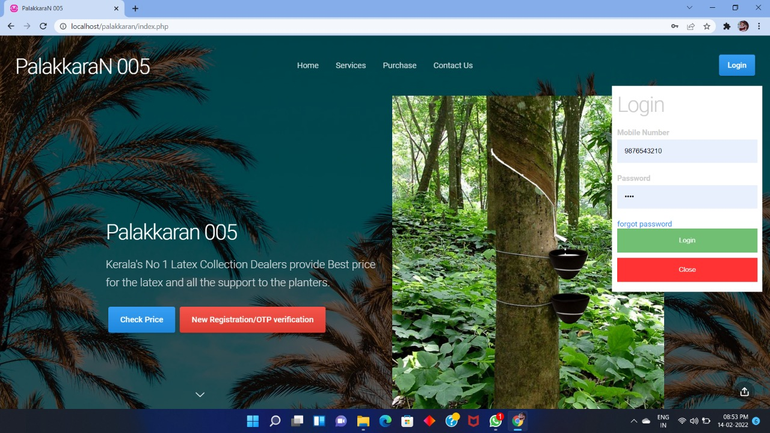

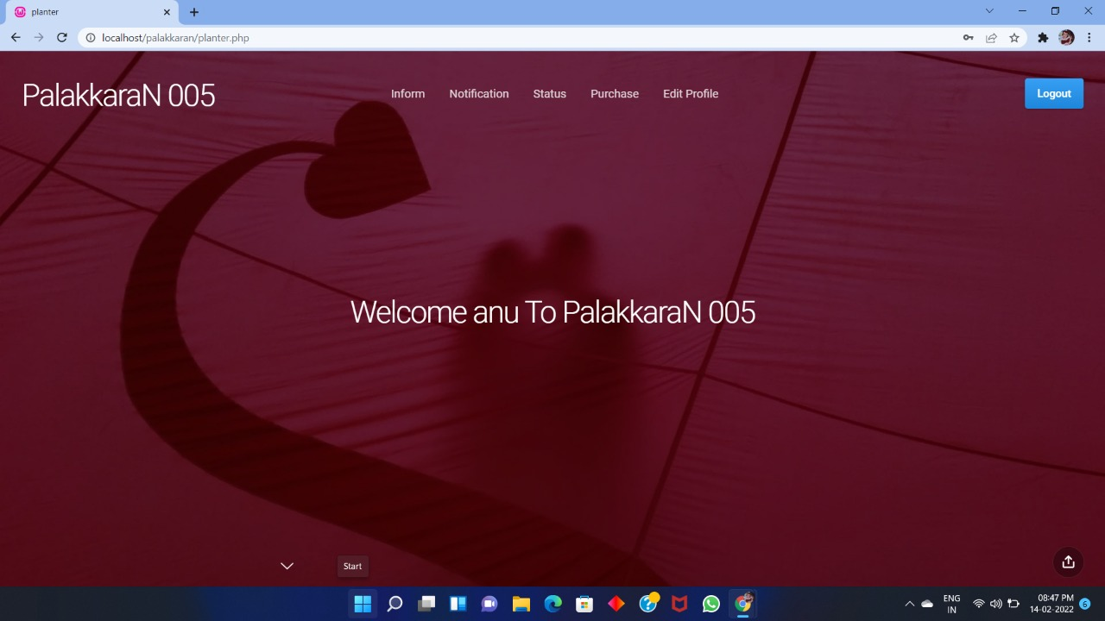

**USER**

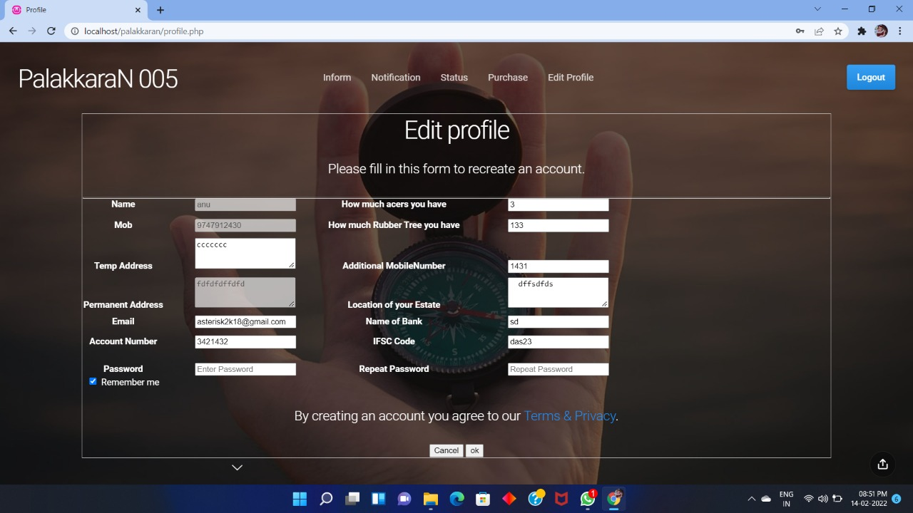

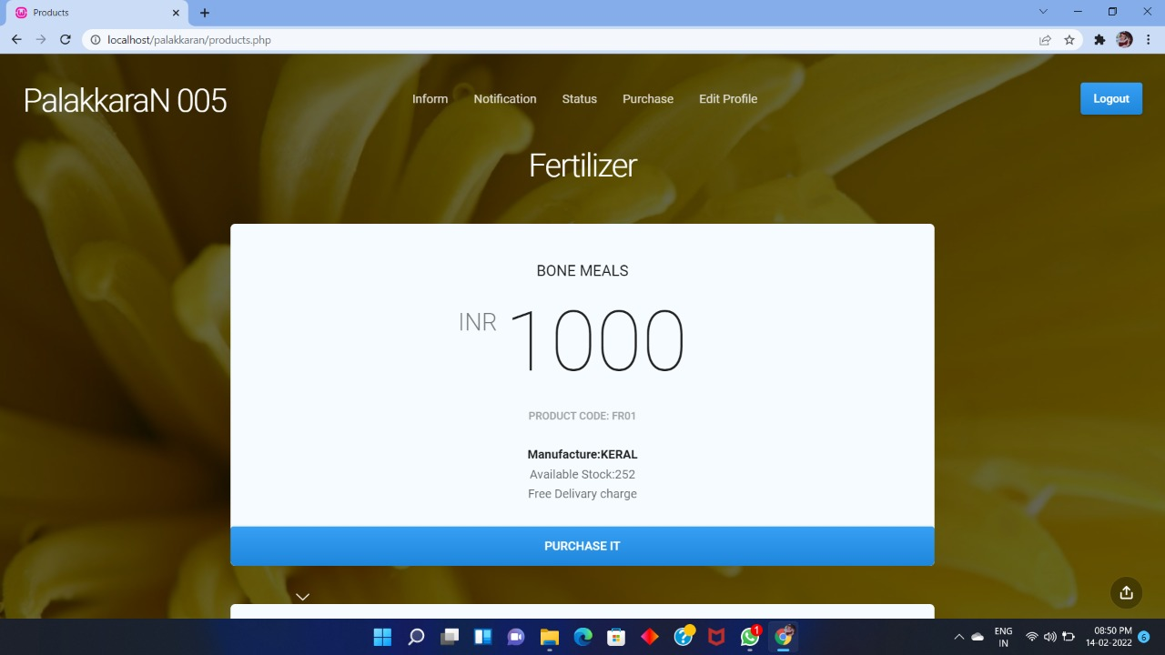

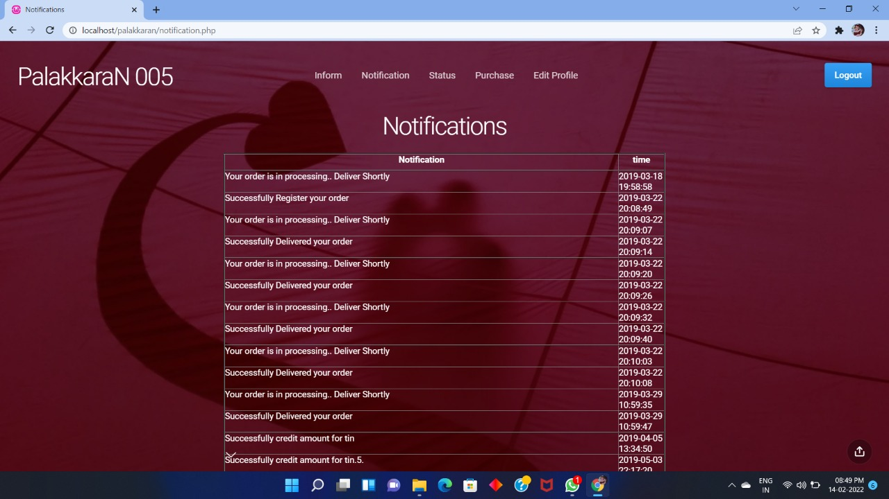

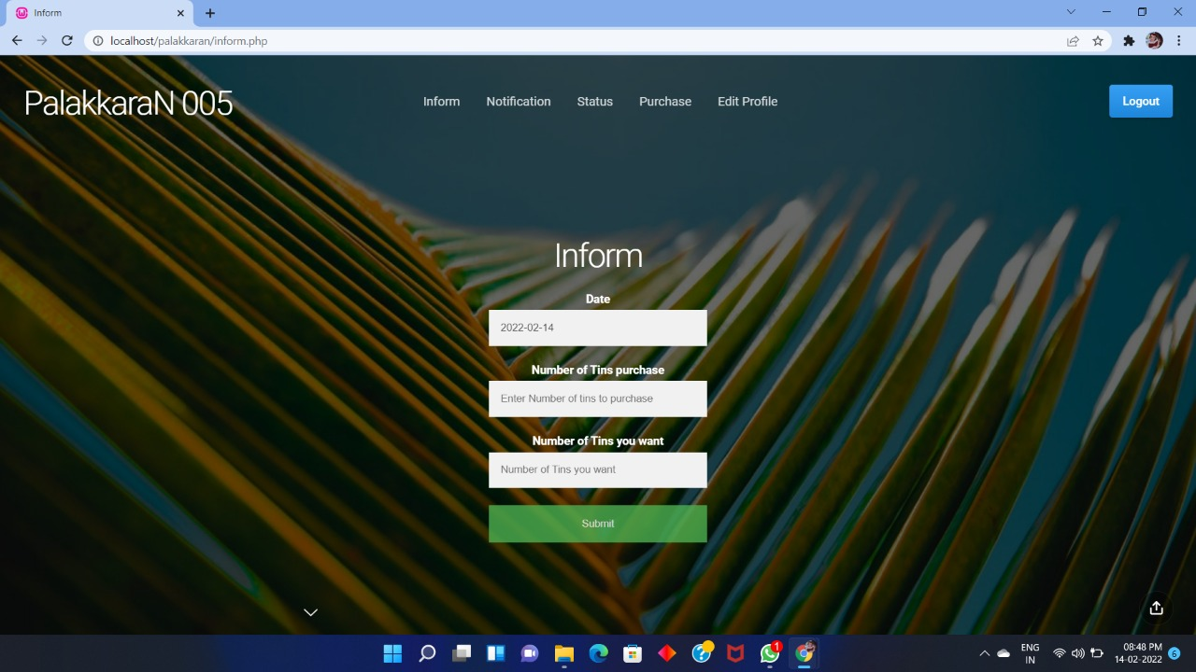

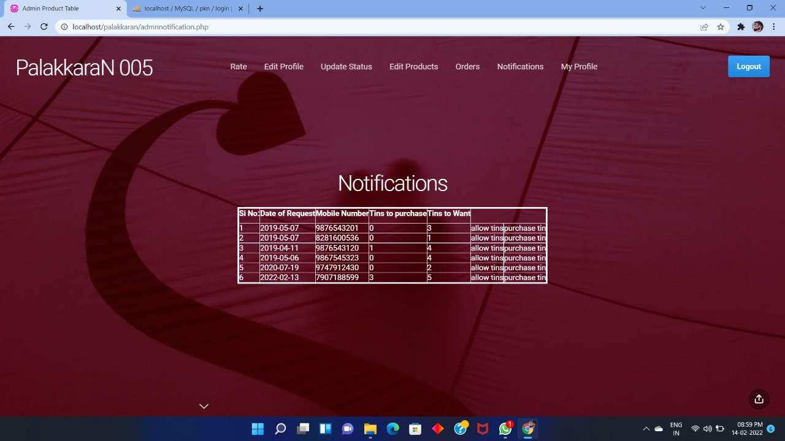

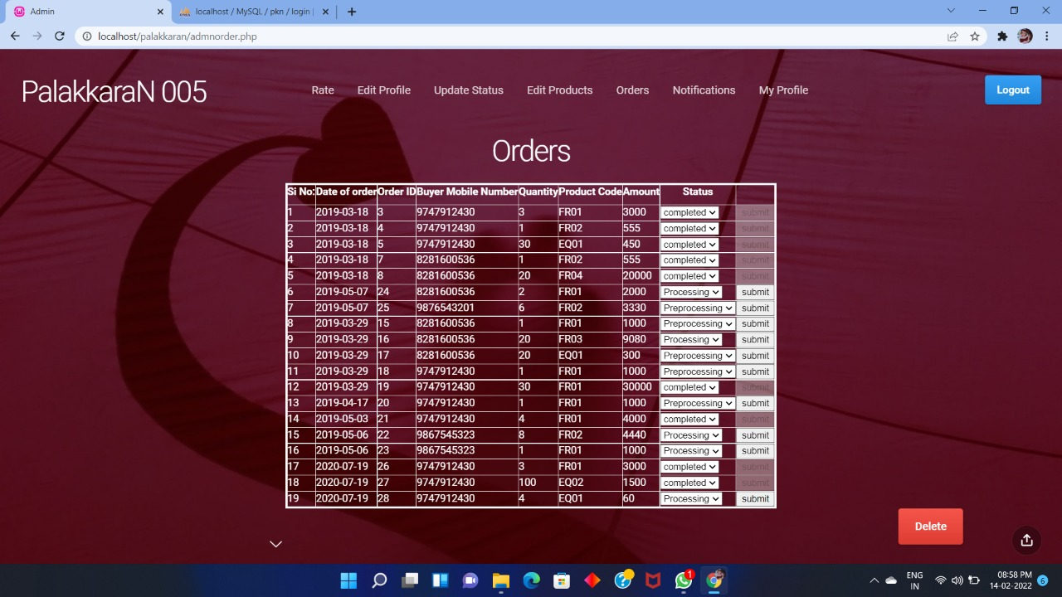

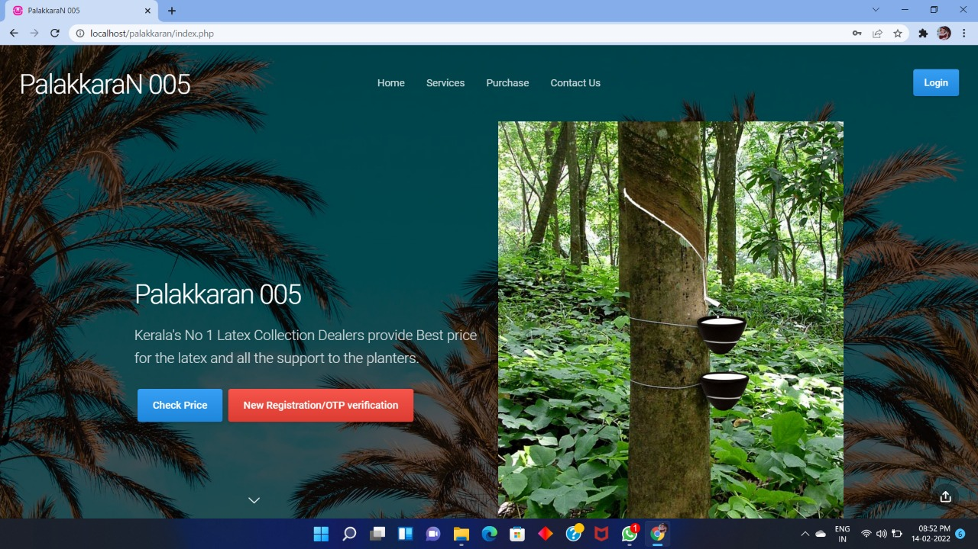

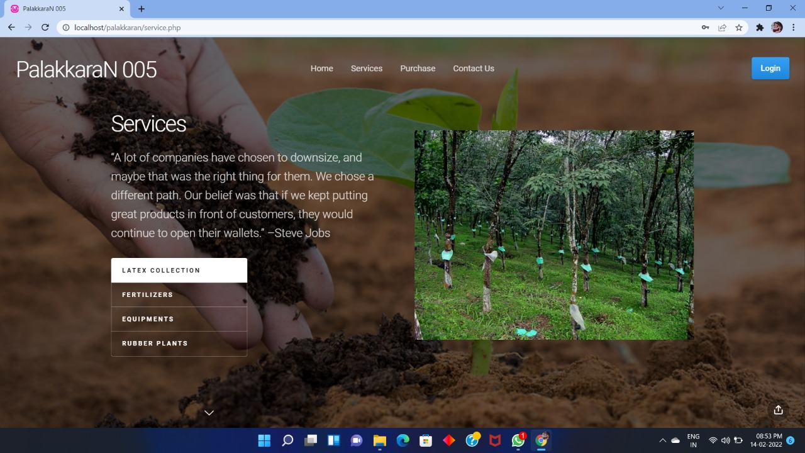

**10.** **CONCLUSION**

The project will result in efficient working of the operation done in the website latex purchasing Rubber Company. Implementation of this project can help the user to easy to know this website it is also reduce the manual effort

**11.** **REFERENCES**

* [www.w3school.com](http://www.w3school.com/)
* [www.tutorialspoint.com](http://www.tutorialspoint.com/)